Week 3

I T 4 - Demonstrate sorting data in a program:

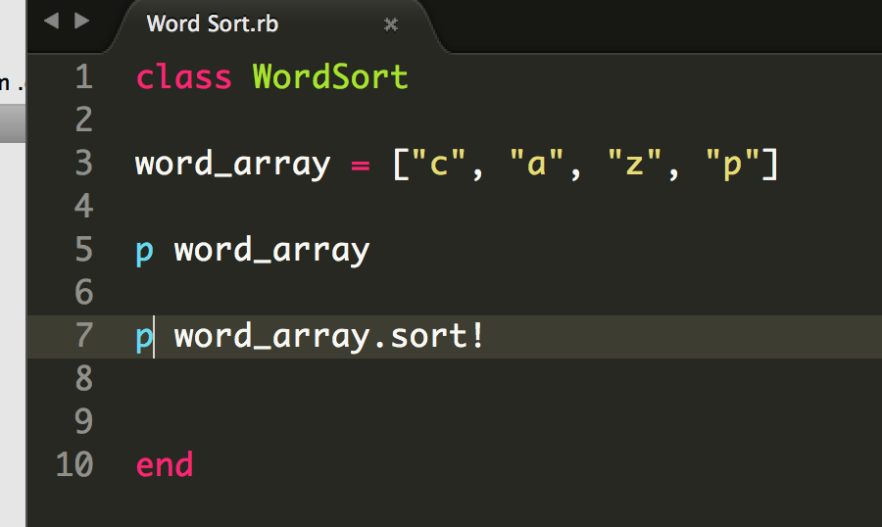

The result of word_array.sort! Is :

["a", "c", "p", "z"]